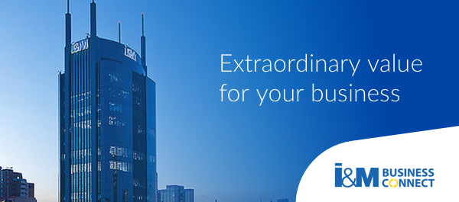
I&M BUSINESS CONNECT INTEGRATION CHECKLIST
- Do you have an Enterprise Resource Planning System (ERP)? If yes?
- Which ERP and the version does the organization use?
- Do you have internal ICT Support?
- Do you have vendor support for integrations?
- Do you have an integration module/API to your accounts module?
- What module do you use and how does it work?
- How do you classify your accounting records? Are they associated with a unique identifier/ reference e.g student id?
- Have you ever extended the functions of your ERP system to include other functionalities?
- Can your organization ERP consume an API?
- How frequently do you upgrade your ERP? What are your future upgrade plans?
- Do you have a separate and independent test environment for the current version of ERP?
- What are the key objectives of the integration? What business needs do you want to solve?
- What integration would you prefer?(i.e. M-Pesa Till, Mpesa short code, Mpesa Paybill or Business connect( pesalink ,RTGS ,branch cash/Cheque, Mpesa)

